Review

**Research / Pre-requisite knowledge**

Links

[AlienKevin/canto_ocr · Hugging Face](https://huggingface.co/AlienKevin/canto_ocr)

[Chinese OCR - a Hugging Face Space by OFA-Sys](https://huggingface.co/spaces/OFA-Sys/OFA-OCR)

[pytesseract · PyPI](https://pypi.org/project/pytesseract/)

[Microsoft PowerToys | Microsoft Learn](https://learn.microsoft.com/en-us/windows/powertoys/)

[Azure AI Document Intelligence | Microsoft Azure](https://azure.microsoft.com/en-us/products/ai-services/ai-document-intelligence)

[Accelerating Document AI (huggingface.co)](https://huggingface.co/blog/document-ai)

[cloud.google.com/document-ai](https://cloud.google.com/document-ai)

<https://adoption.microsoft.com/en-us/intelligent-document-processing/>

<https://vocus.cc/article/63fe0555fd89780001009dc3>

Some introduction (10/1/2023)

<https://www.youtube.com/watch?v=O673mX9n9Rw>

<https://www.youtube.com/watch?v=TX7XwwIG5lw>

<https://www.youtube.com/watch?v=P4Z8_qe2Cu0>

Transformers

[何謂 Transformer 模型？ - NVIDIA 台灣官方部落格](https://blogs.nvidia.com.tw/2022/06/21/what-is-a-transformer-model/)

[🤗 Transformers (huggingface.co)](https://huggingface.co/docs/transformers/index)

[Accelerating Document AI (huggingface.co)](https://huggingface.co/blog/document-ai)

YOLOv5 - v7

[YOLOS (huggingface.co)](https://huggingface.co/docs/transformers/model_doc/yolos)

Donut (no OCR required for en/zh/kr/jp)

[GitHub - clovaai/donut: Official Implementation of OCR-free Document](https://github.com/clovaai/donut)

[OCR-free Document Understanding Transformer | Papers With Code](https://paperswithcode.com/paper/donut-document-understanding-transformer)

[Donut:不用OCR中间过程也能理解图片文档 - 知乎 (zhihu.com)](https://zhuanlan.zhihu.com/p/633696599)

Microsoft (LayoutLMv3, Document classification)

[microsoft/layoutlmv3-base · Hugging Face](https://huggingface.co/microsoft/layoutlmv3-base)

[Engineering Explained: LayoutLMv3 and the Future of Document AI | KUNGFU.AI Blog](https://www.kungfu.ai/blog-post/engineering-explained-layoutlmv3-and-the-future-of-document-ai)

10/6/2023

[快速理解Pre-Trained Model、Transfer Learning之間差異，並且實作PyTorch提供的Pre-Trained Model | by 嘉鈞張 | Medium](https://chiachun0818.medium.com/%E5%BF%AB%E9%80%9F%E7%90%86%E8%A7%A3pre-trained-model-transfer-learning%E4%B9%8B%E9%96%93%E5%B7%AE%E7%95%B0-%E4%B8%A6%E4%B8%94%E5%AF%A6%E4%BD%9Cpytorch%E6%8F%90%E4%BE%9B%E7%9A%84pre-trained-model-4a246a38463b)

[What is Zero-Shot Classification? - Hugging Face](https://huggingface.co/tasks/zero-shot-classification)

[Knowledge distillation - Wikipedia](https://en.wikipedia.org/wiki/Knowledge_distillation)

[RVL-CDIP Dataset | Papers With Code](https://paperswithcode.com/dataset/rvl-cdip)

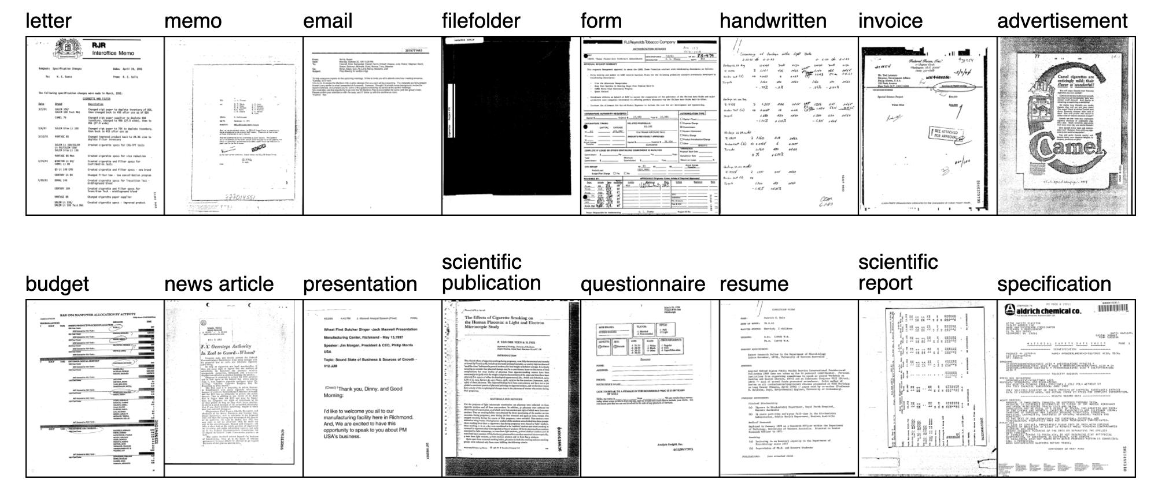

10/7/2023

Pre-trained model with adaptation

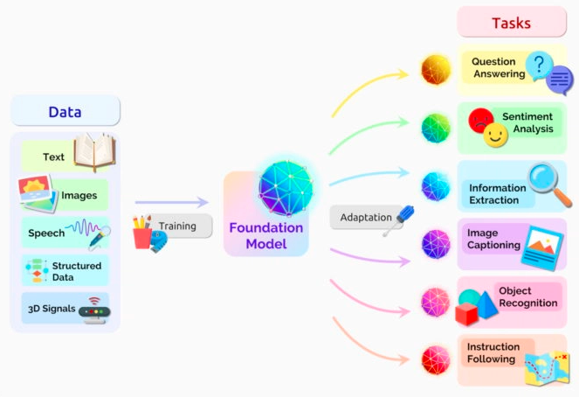

Document Image Classification on RVL-CDIP

https://paperswithcode.com/sota/document-image-classification-on-rvl-cdip

Tobacco3482 dataset

<https://paperswithcode.com/sota/document-image-classification-on-tobacco-3482>

[Document Classification: A Complete Guide (levity.ai)](https://levity.ai/blog/document-classification-guide)

10/11/2023

10/12/2023

[簡介機器學習＆深度學習 - iT 邦幫忙::一起幫忙解決難題，拯救 IT 人的一天 (ithome.com.tw)](https://ithelp.ithome.com.tw/articles/10317800)